PROJECT REPORT
BY MUHAMMAD SHAYAN,
SUFYAN ALI AND HAMZA AHMED
TITLE: SNAKE GAME
INTRODUCTION:
The aim of creating snake game is to modify the user about the new advanced level in snake game which opens a challenging mode for everyone. It provides the user a new interface in which it can play in their free time .
BACKGROUND (RESEARCH AND PROJECT SELECTION):
The selection of project is completed by the research in other games, where snake game found no such details so snake game becomes a superior decision to us. In the completion of this project, the necessary assistance met from w3 resource where the overview and the function are used to complete it.

Project Specification:
The time required to complete the project is distributed by our group partners equally by separating functions in code. It has the feature of time limits and walls as obstacles and snake doesn’t grow after eating food. It has the functionality to create a bit difficulty in snake game. It has the features of making 2 by 2 length width where snake can travel in it. The snake will circulate in the box.it will proceed to right, left, up and down directions. The snake needs user instructions to get move.
Problem analysis:
Moreover, snake games are entertaining, but once a player plays them, they may become repetitive, predictable and lack a competitive aspect. They tend to be long, time wasting, thus making the game boring. These problems can be improved by adding a couple of new features to the game and its design.
Solution Design (Project Detail, Functionality and features)
It has the features of hurdles in it where the user by its own method of instruction tend to reach the food in time will get win. However, the snake is represented in this project by ‘O’. The hurdles are represented by X. the fruit is represented by ‘F’. The snake is present in this game is at center and food is present at different location at different time by using random functions rand().The game has the another features as well such as :difficulty level in moving the snake from center to food to get finished on time. 4 separate functions have been used to complete this project one for sketching, second one for input from user, third one is movement of fruit, fourth one is for position of obstacles.

Implementation & Testing:
It has the power of creating the mindful use in testing the game to pass the snake from its initial position to desired position. However, this project is tested on dev c++ where it was started.
It contains lots of error in beginning after testing and resorting it get the desired output.
Project Breakdown Structure (Workload distribution with timeline):
The project required hardly one week in 3 to 4 hours in a day to get the desired result. However, the project is distributed in couple of functions to the partners to get work load distributed.
Results (Outputs screenshots):
It is showing this interface on running

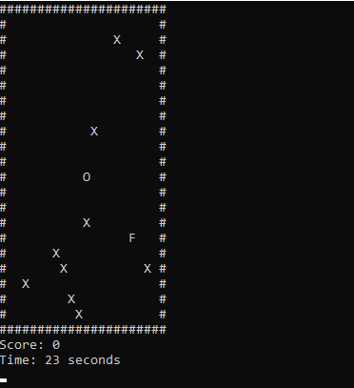
After get hit by the walls, the game over. The game also shows the timer.
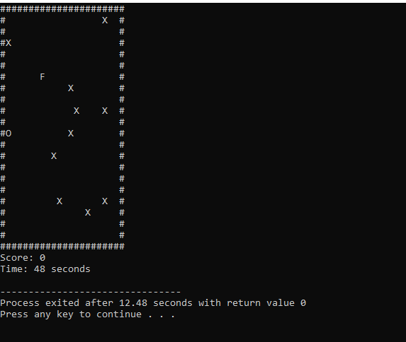
The snake also doesn’t grow in length when eaten foods.
CONCLUSION(SUMMARY AND DISCUSSION):
As mentioned, all the requirements are meets which stated in the proposal. As project makers highly recommends this game to be used in future for gaming. All of its features are discussed ,so we hope that this game gains such high popularity.

